**Creating a PHP Template**

**Setting up the File structure and Folders**

**Step One**

Let’s start by creating a new folder. I have named this folder php_site.

Inside of this folder we are now going to create two new files. One is index.html and the other file is going to be named style.css

**Step Two**

Now we are going to create two more folders inside of our main folder. The first folder is going to be named includes, and the second folder will be named variables.

We should now have a setup that looks like the following: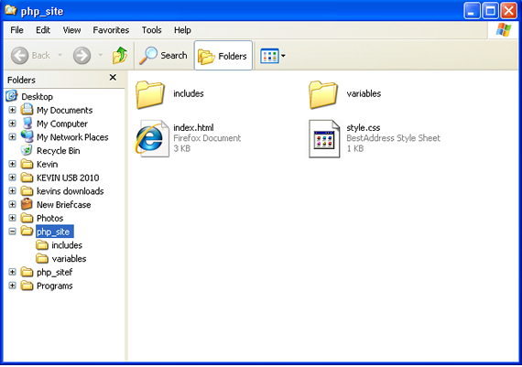

### Step Three

Now, using your favorite html editor open the index.html file. We are going to to create a basic html website document. This is the code I am using:

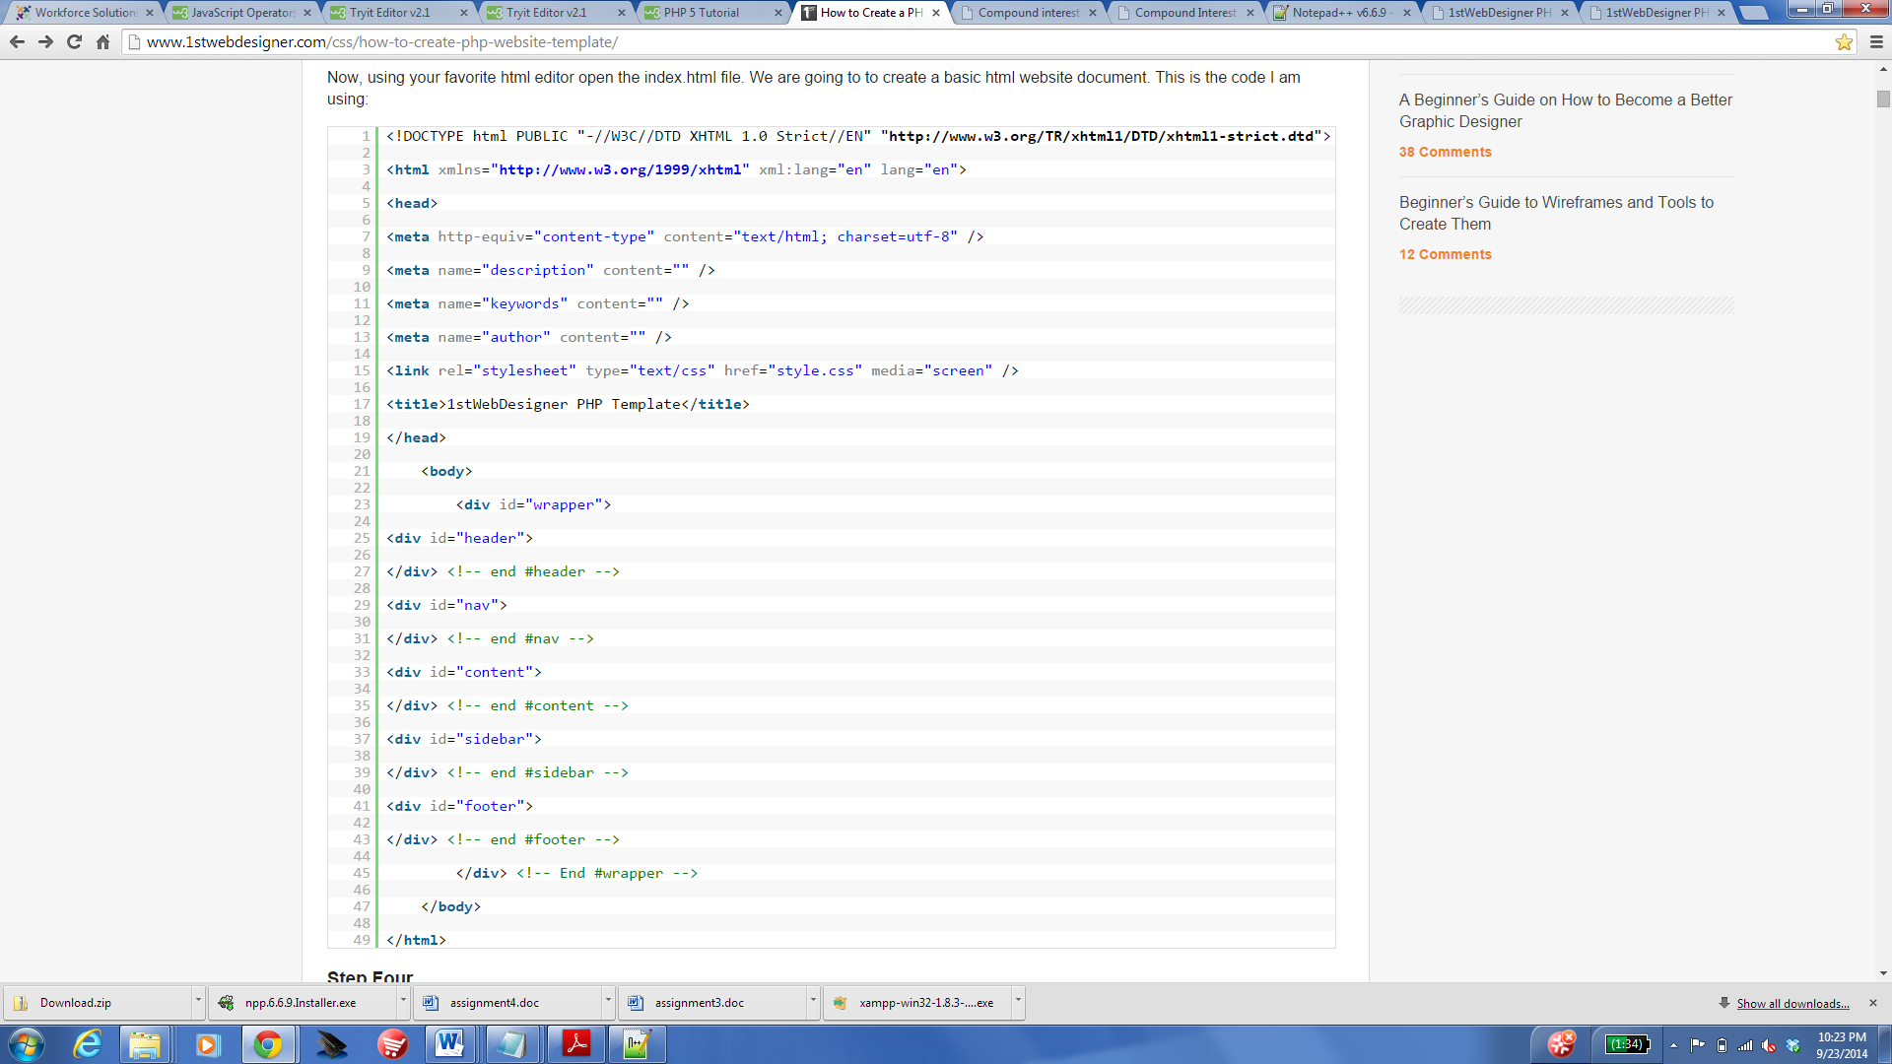

### Step Four

Now I am going to open up the style.css file and add the divs we will be using. I have added very basic styling so you can see the site and get the idea of what we are doing. Remember that you can use your own styling when creating your website to suit your needs.

This is the CSS I am adding to the stylesheet:

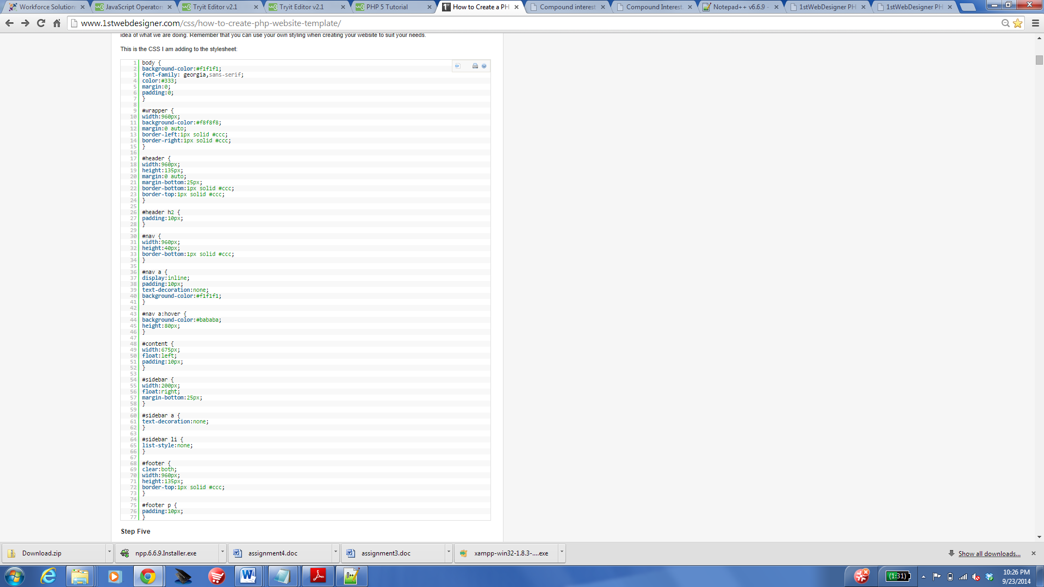

### Step Five

Next we will create some more files that we will be using when we start converting our template to php.

Open up the folder we created inside of our main folder called variables. Next, create a blank file called variables.php

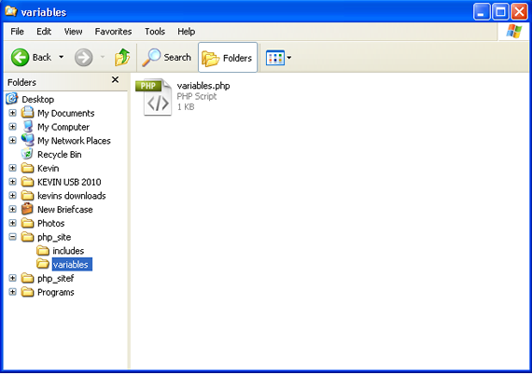

Then go into the other folder we created called includes and create the following files:

header.php  
nav.php  
sidebar.php  
footer.php

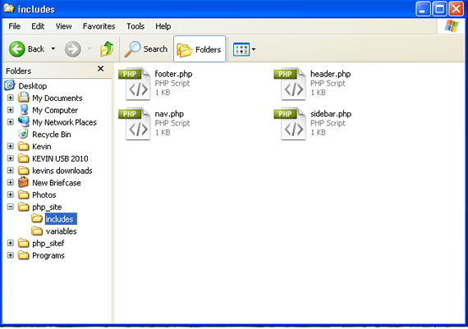

### Step Six

Now we will need to add some content to our index.html file. I have filled in the header area with an H2 tag for the website header title. I will also be adding the links in the nav area, as well as some text in the content area, sidebar, and footer. The final index.html file now looks like this:

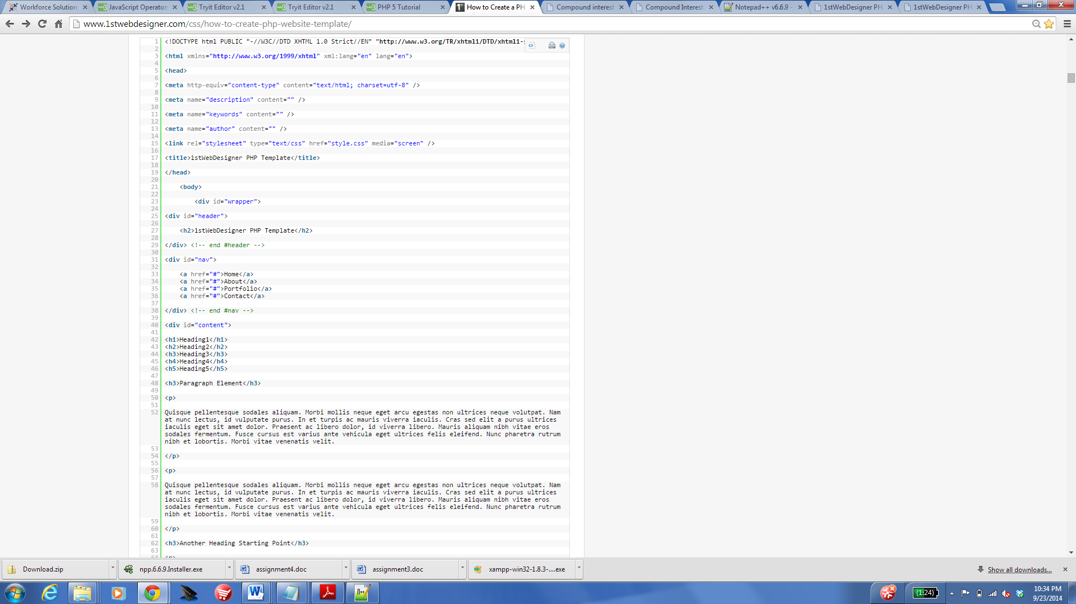

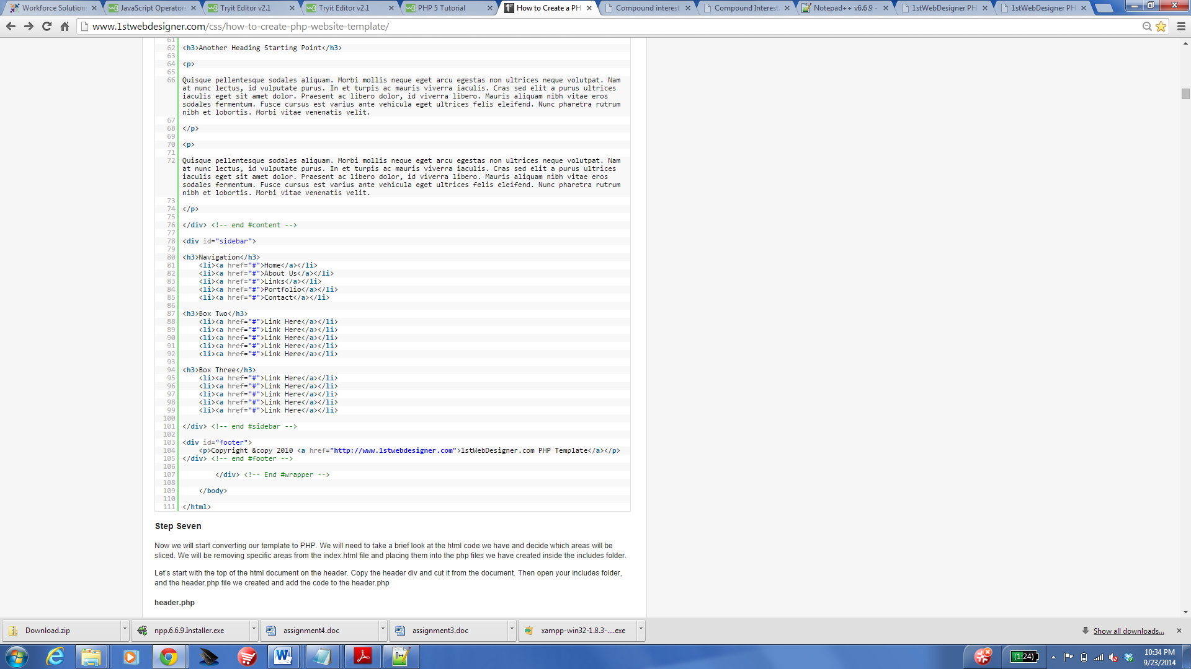

### Step Seven

Now we will start converting our template to PHP. We will need to take a brief look at the html code we have and decide which areas will be sliced. We will be removing specific areas from the index.html file and placing them into the php files we have created inside the includes folder.

Let’s start with the top of the html document on the header. Copy the header div and cut it from the document. Then open your includes folder, and the header.php file we created and add the code to the header.php

#### header.php

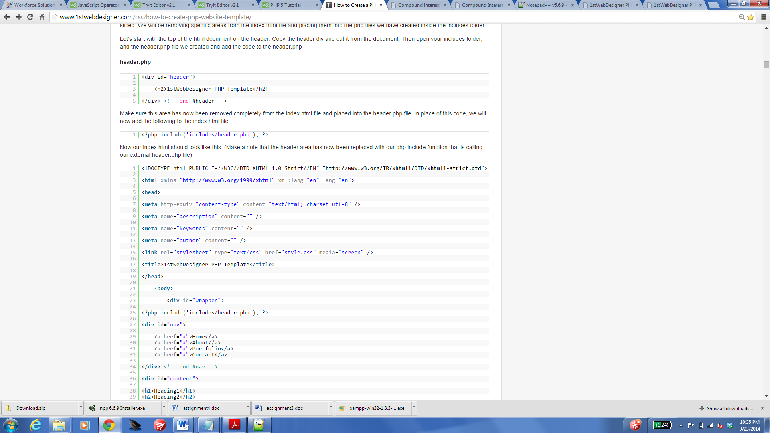

Make sure this area has now been removed completely from the index.html file and placed into the header.php file. In place of this code, we will now add the following to the index.html file.



Now our index.html should look like this: (Make a note that the header area has now been replaced with our php include function that is calling our external header.php file)

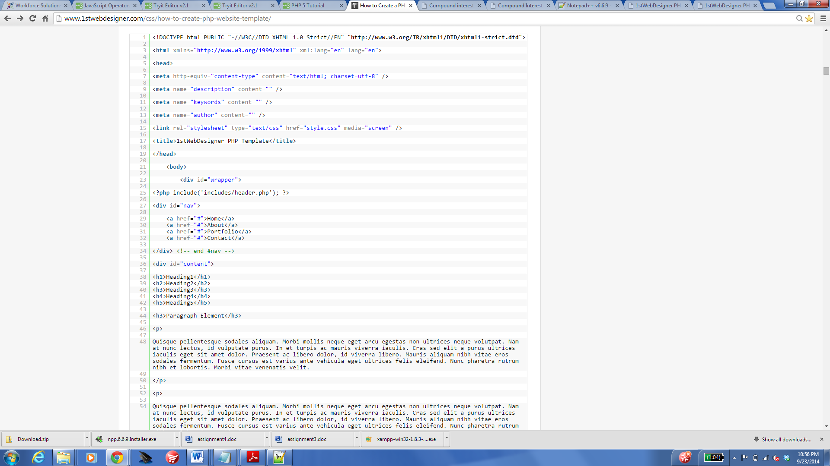

### Step Eight

Now we will continue to slice the html document and place the code in the proper php files we made.

Next let’s move to the nav div. The same as above, we are going to copy and cut that piece of code and place it into our nav.php file that is located inside of the includes folder.

This is what we are adding to the nav.php file:

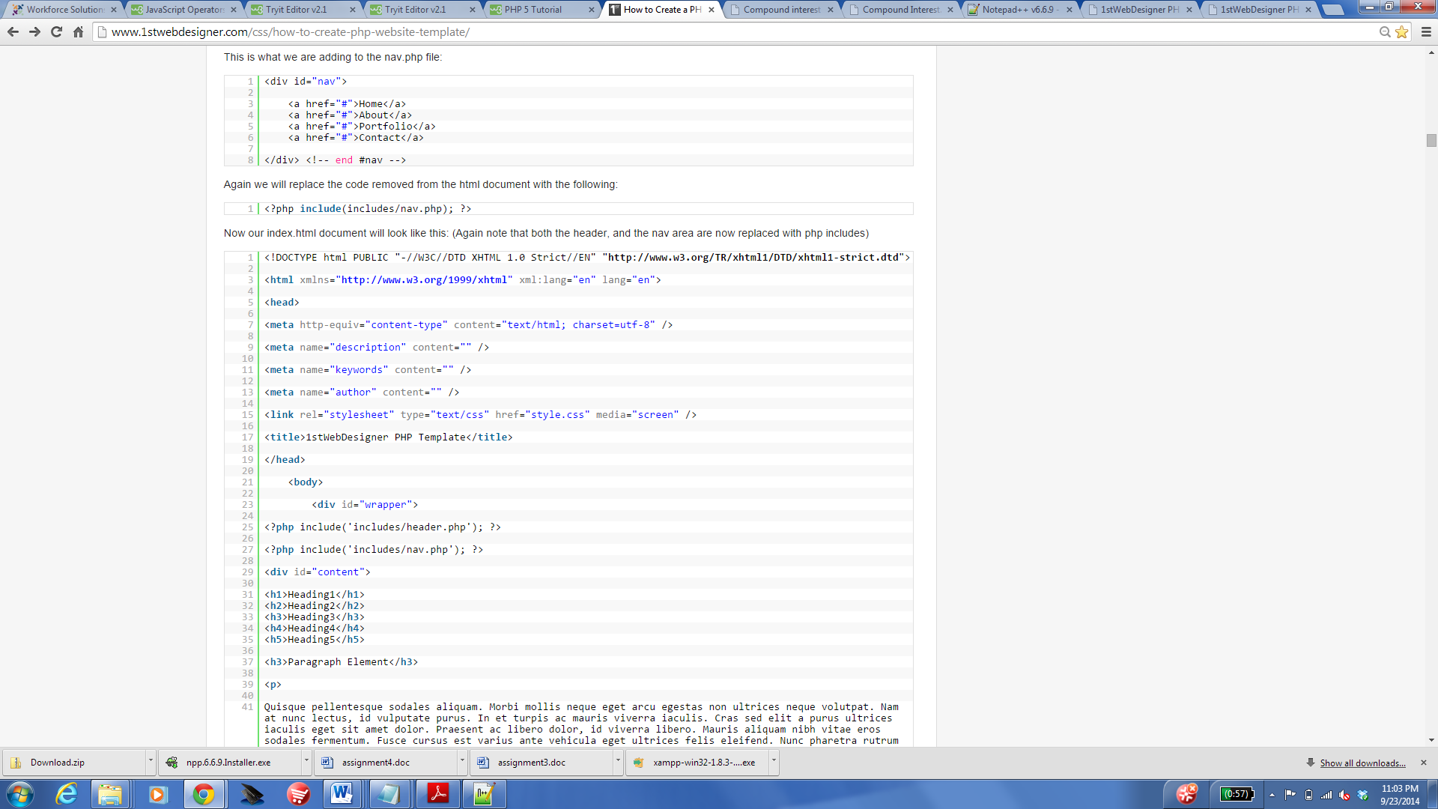

Again we will replace the code removed from the html document with the following:



Now our index.html document will look like this: (Again note that both the header, and the nav area are now replaced with php includes)



### Step Nine

Now it is time to do the sidebar. Copy and cut the sidebar div and place it into the sidebar.php file we created that is located inside the includes folder.

This is the code we are adding:

#### sidebar.php

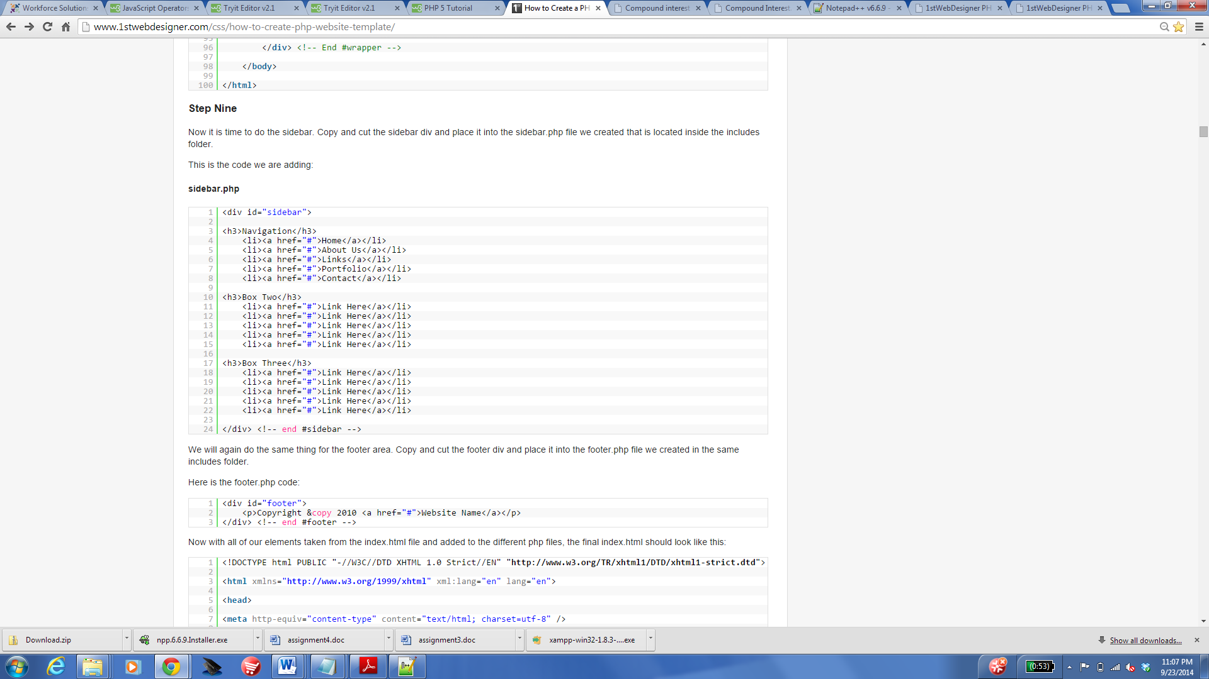

We will again do the same thing for the footer area. Copy and cut the footer div and place it into the footer.php file we created in the same includes folder.

Here is the footer.php code:



Now with all of our elements taken from the index.html file and added to the different php files, the final index.html should look like this:

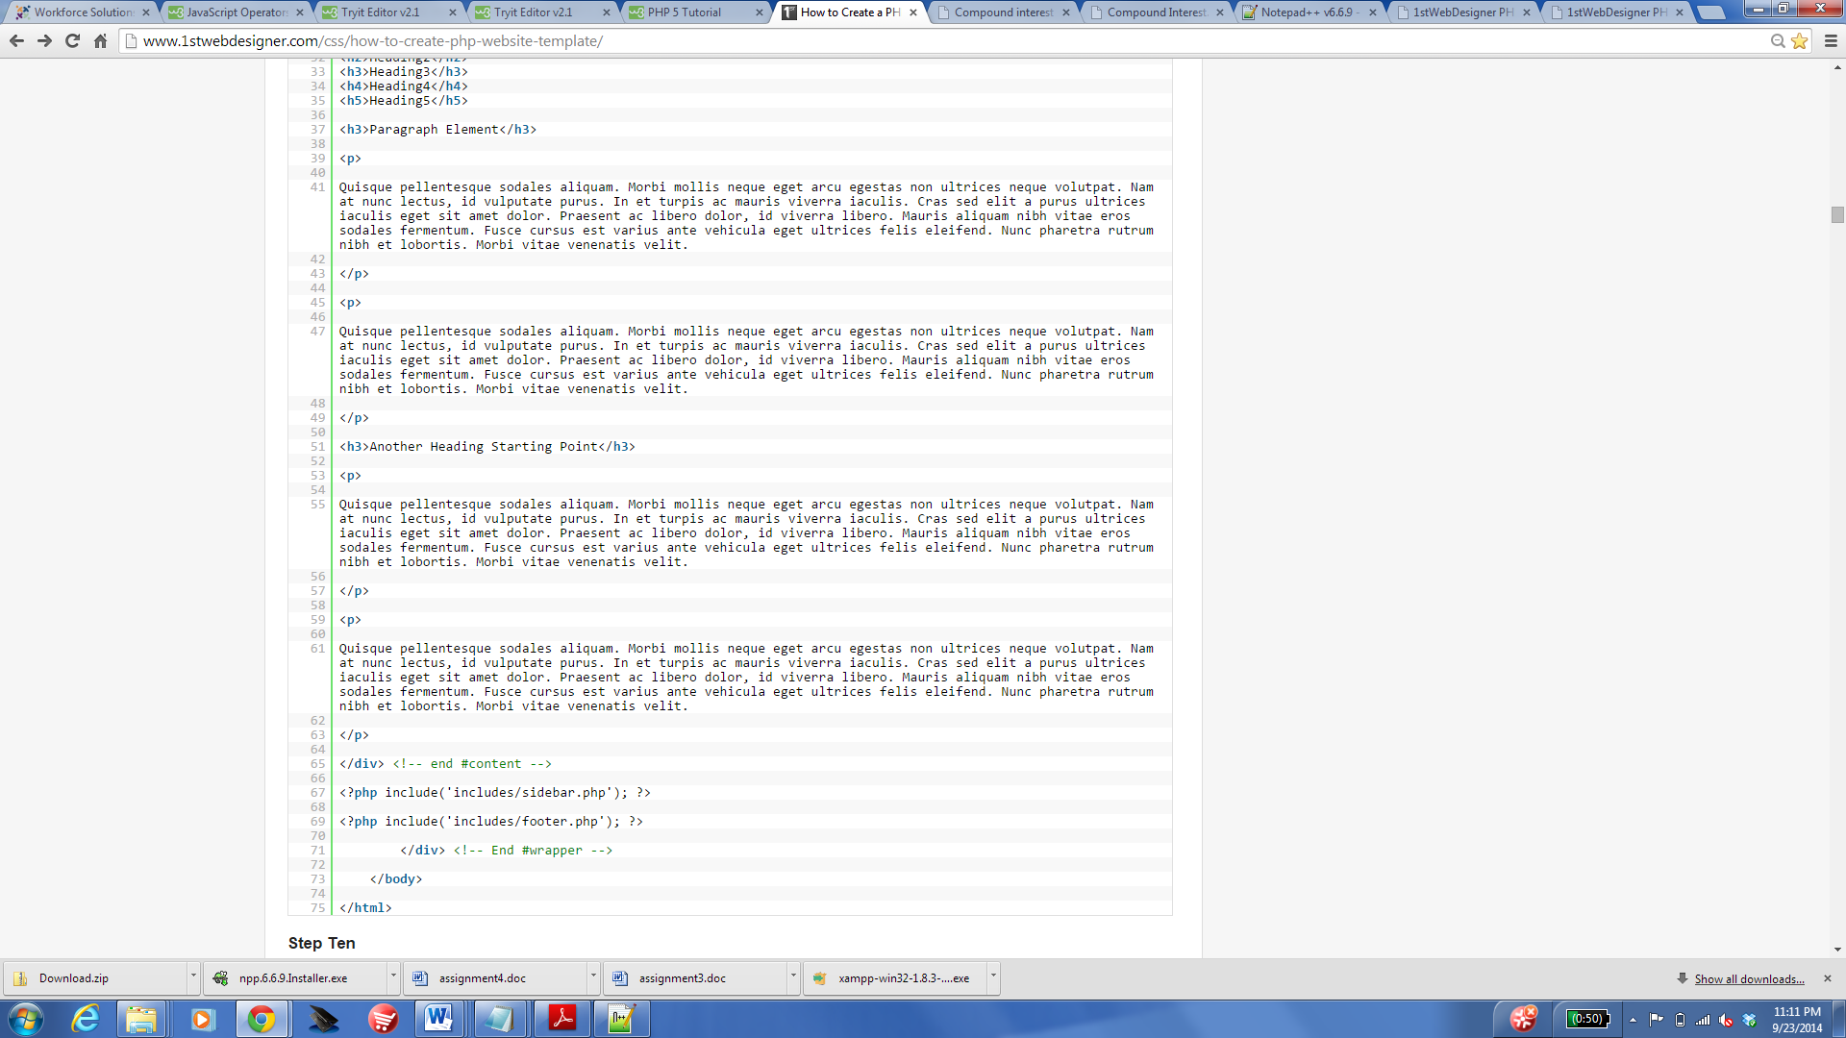

### Step Ten

Now that our index.html is properly sliced, we can rename the index.html file to index.php

Now that we have created this template, as long as the php includes are on any page we only have to modify the one single file to make it visible accross your entire website. This again is good for anyone with a lot of content and pages. Instead of having to edit the sidebar on every page of your site you can now just edit the sidebar.php file and it will reflect on all of your pages. This makes it a lot easier to keep up with large portions of website material.

Our folder should now look like this:

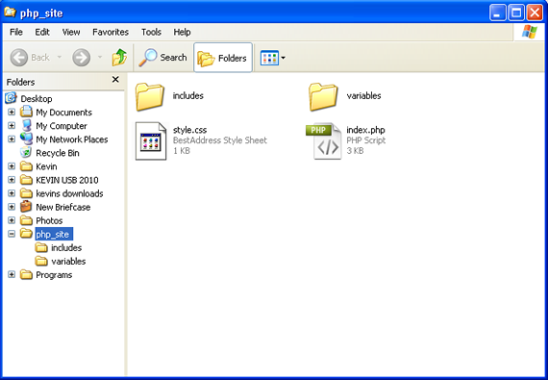

# Creating PHP Variables for the template

Now we will make it a little more dynamic and even easier to be able to modify when needed. Lets take a look at the header.php file inside the includes folder.

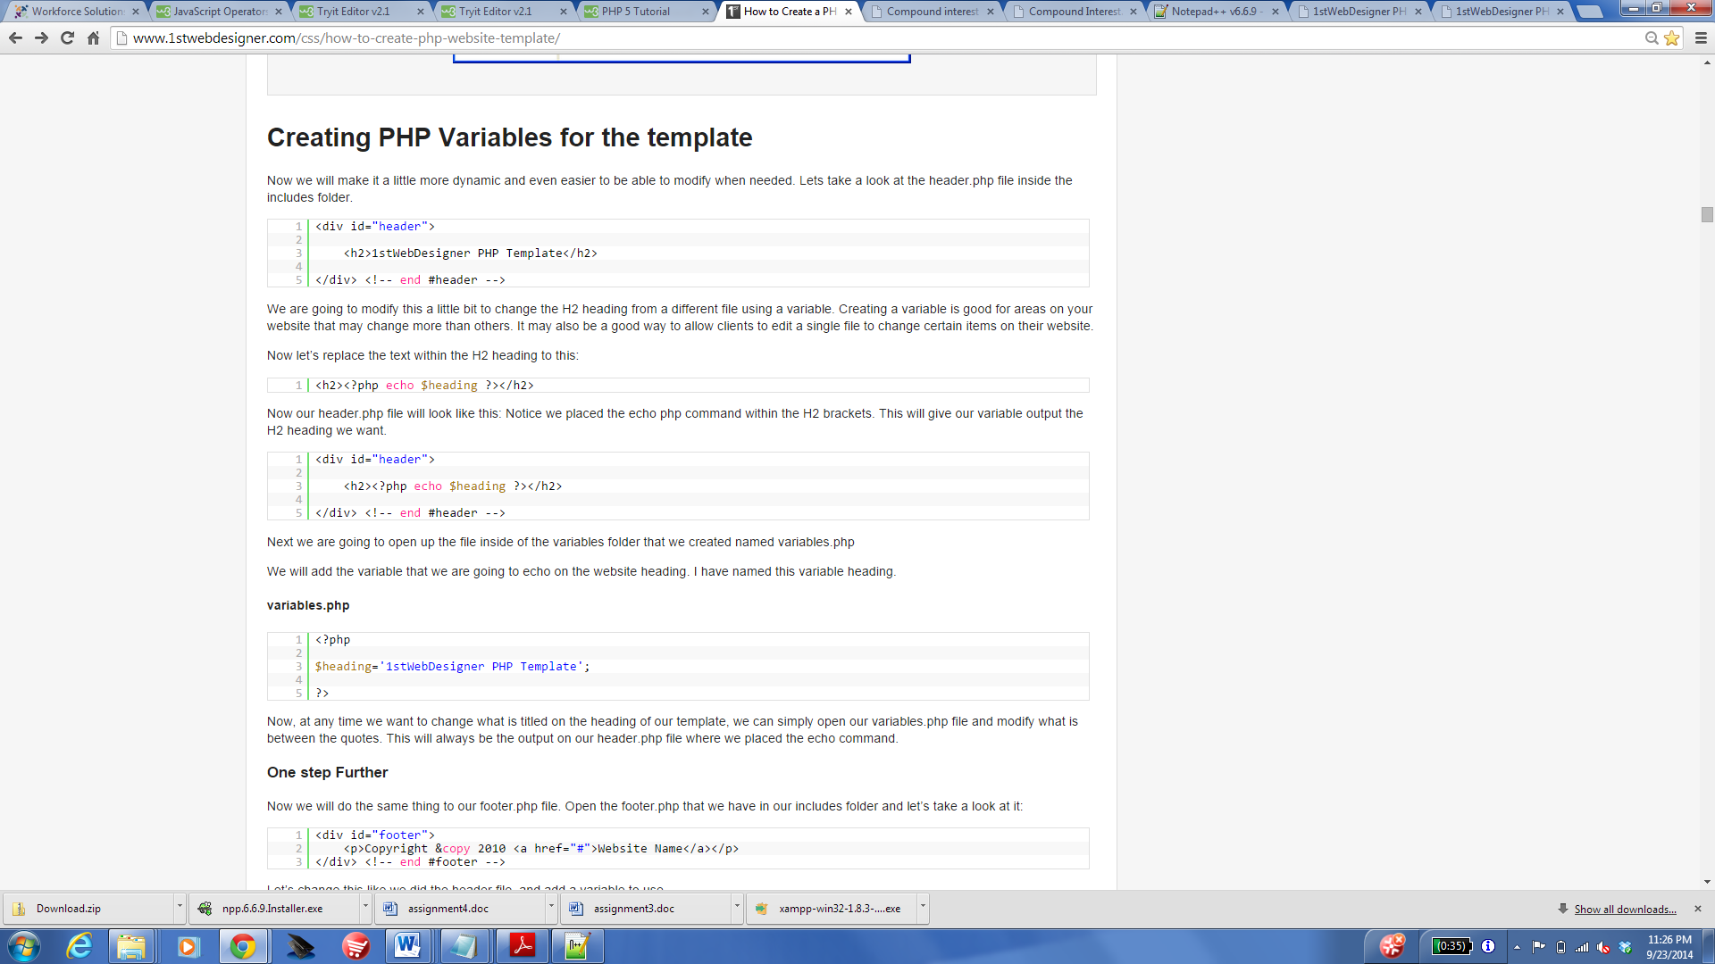

We are going to modify this a little bit to change the H2 heading from a different file using a variable. Creating a variable is good for areas on your website that may change more than others. It may also be a good way to allow clients to edit a single file to change certain items on their website.

Now let’s replace the text within the H2 heading to this:



Now our header.php file will look like this: Notice we placed the echo php command within the H2 brackets. This will give our variable output the H2 heading we want.



Next we are going to open up the file inside of the variables folder that we created named variables.php

We will add the variable that we are going to echo on the website heading. I have named this variable heading.

#### variables.php



Now, at any time we want to change what is titled on the heading of our template, we can simply open our variables.php file and modify what is between the quotes. This will always be the output on our header.php file where we placed the echo command.

### One step Further

Now we will do the same thing to our footer.php file. Open the footer.php that we have in our includes folder and let’s take a look at it:



Let’s change this like we did the header file, and add a variable to use.

We will place our echo command within the paragraph brackets. You should now have the following in your footer.php:

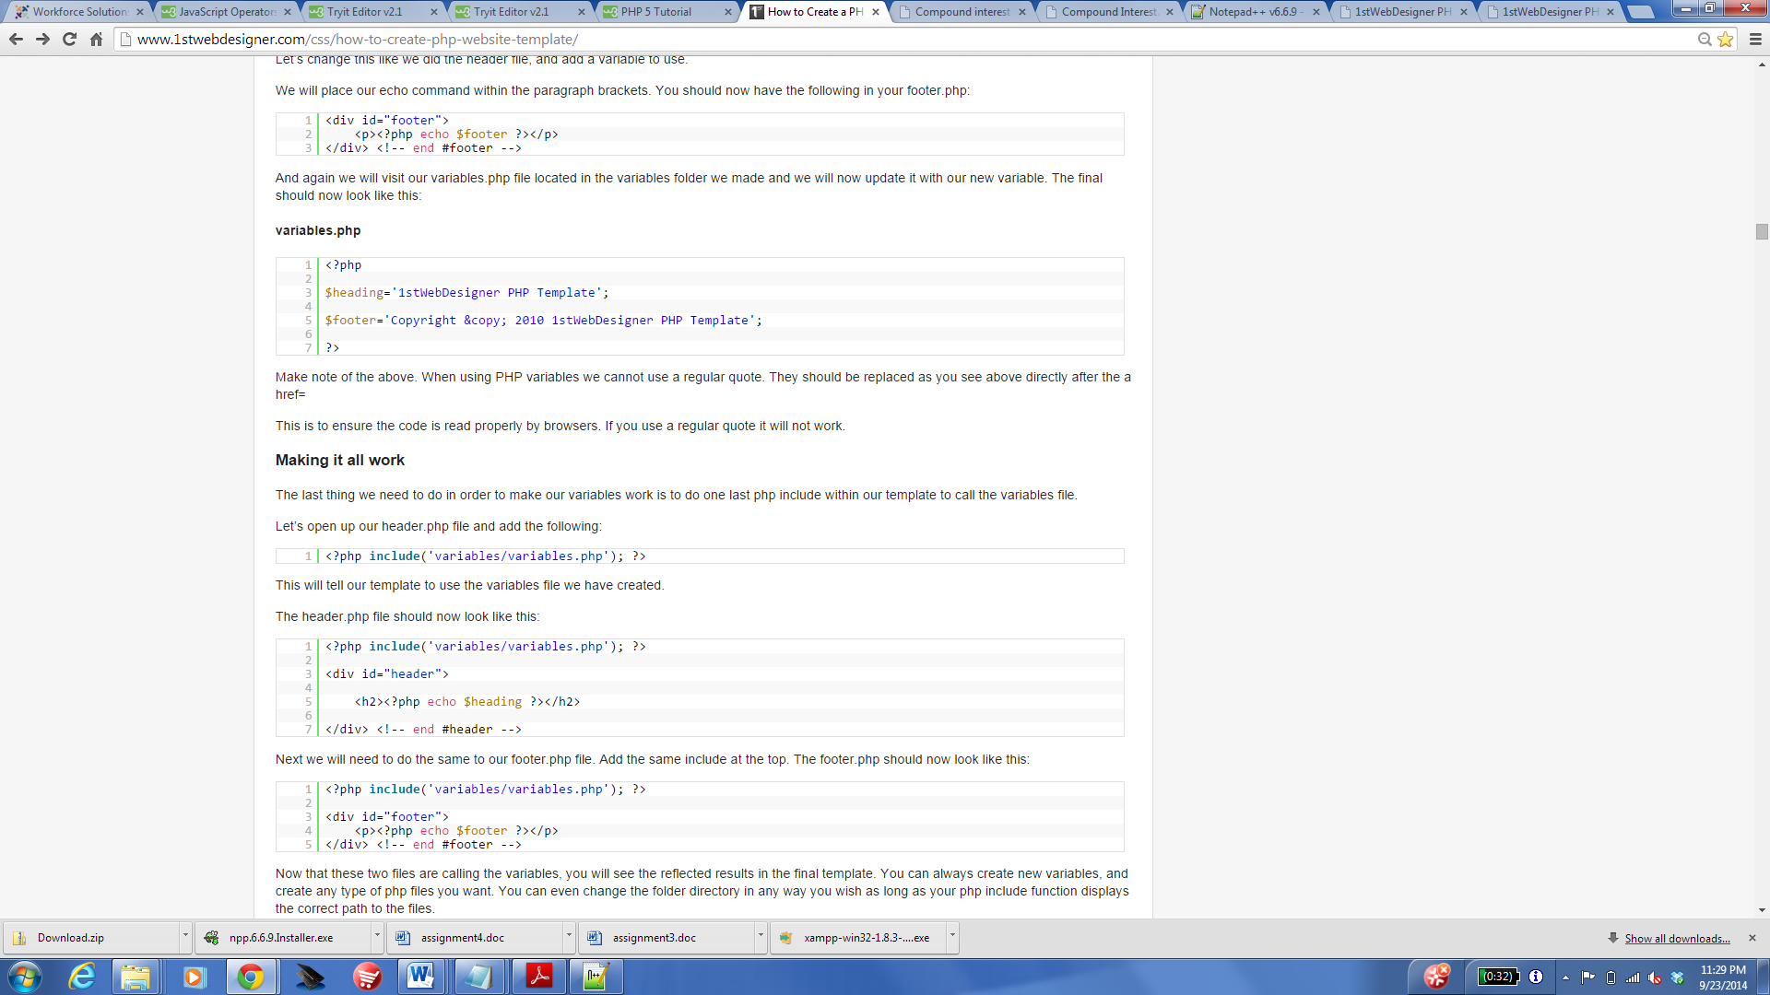

And again we will visit our variables.php file located in the variables folder we made and we will now update it with our new variable. The final should now look like this:

#### variables.php

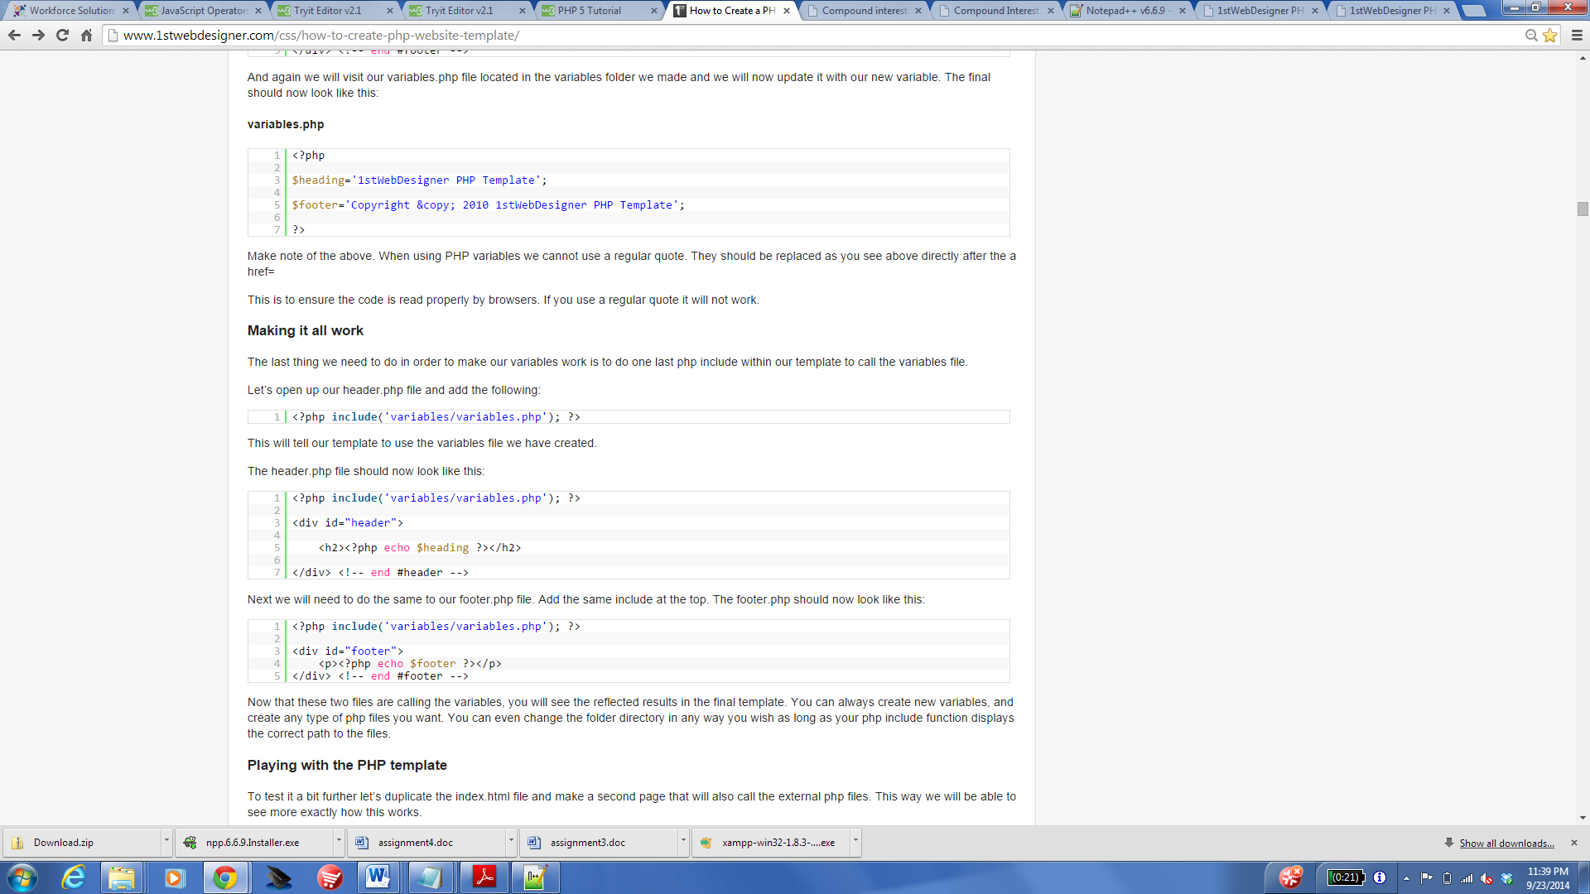

Make note of the above. When using PHP variables we cannot use a regular quote. They should be replaced as you see above directly after the a href=

This is to ensure the code is read properly by browsers. If you use a regular quote it will not work.

### Making it all work

The last thing we need to do in order to make our variables work is to do one last php include within our template to call the variables file.

Let’s open up our header.php file and add the following:

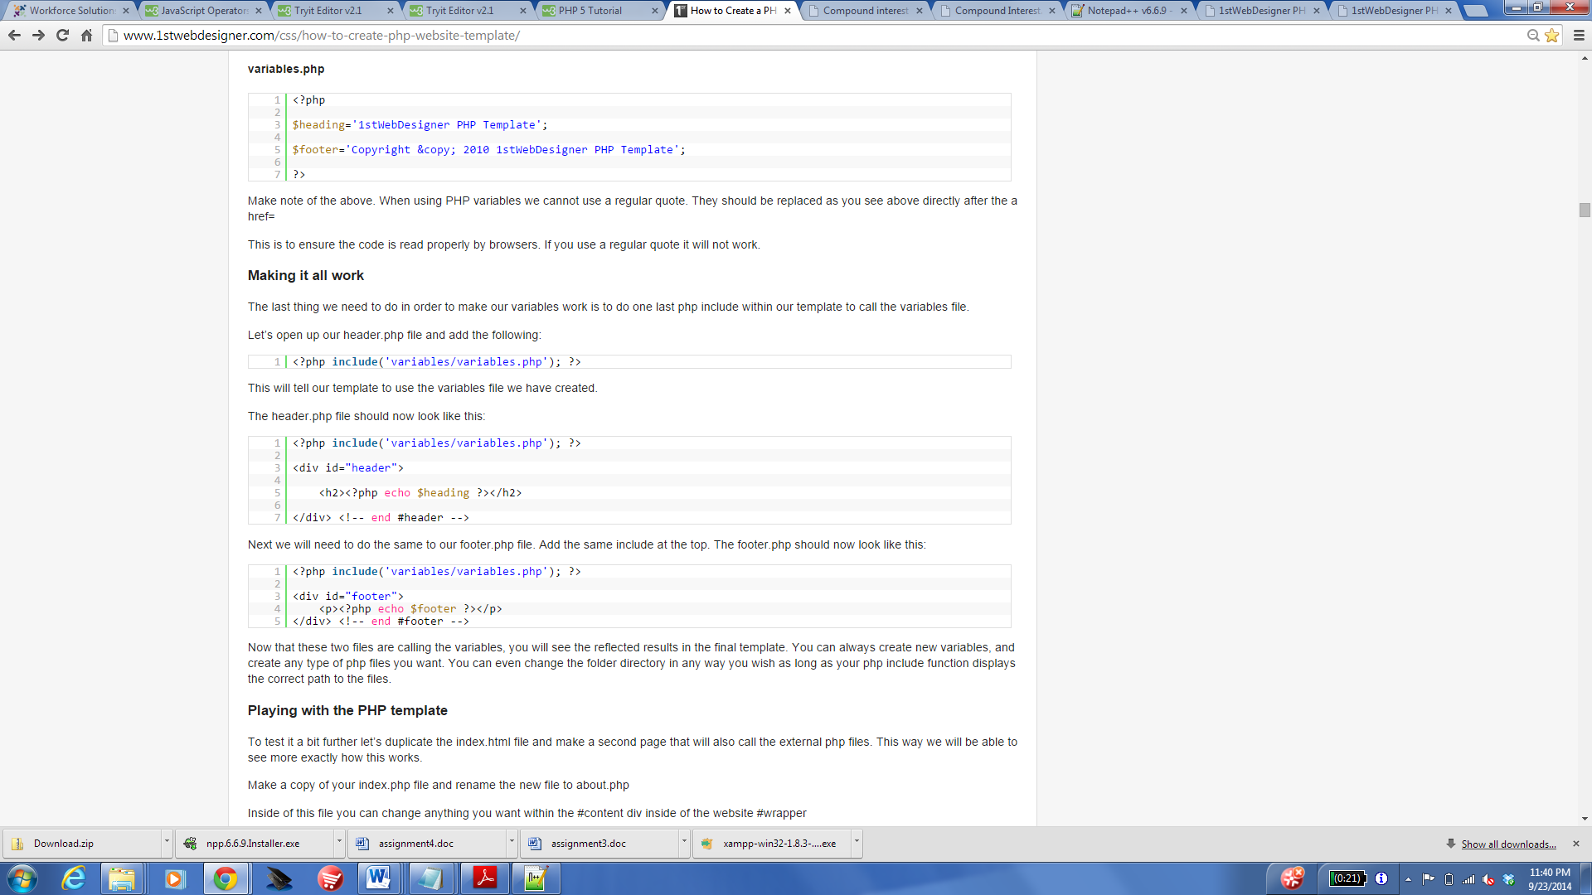

This will tell our template to use the variables file we have created.

The header.php file should now look like this:



Next we will need to do the same to our footer.php file. Add the same include at the top. The footer.php should now look like this:



Now that these two files are calling the variables, you will see the reflected results in the final template. You can always create new variables, and create any type of php files you want. You can even change the folder directory in any way you wish as long as your php include function displays the correct path to the files.

### Playing with the PHP template

To test it a bit further let’s duplicate the index.html file and make a second page that will also call the external php files. This way we will be able to see more exactly how this works.

Make a copy of your index.php file and rename the new file to about.php

Inside of this file you can change anything you want within the #content div inside of the website #wrapper

I have created the following for testing purposes:

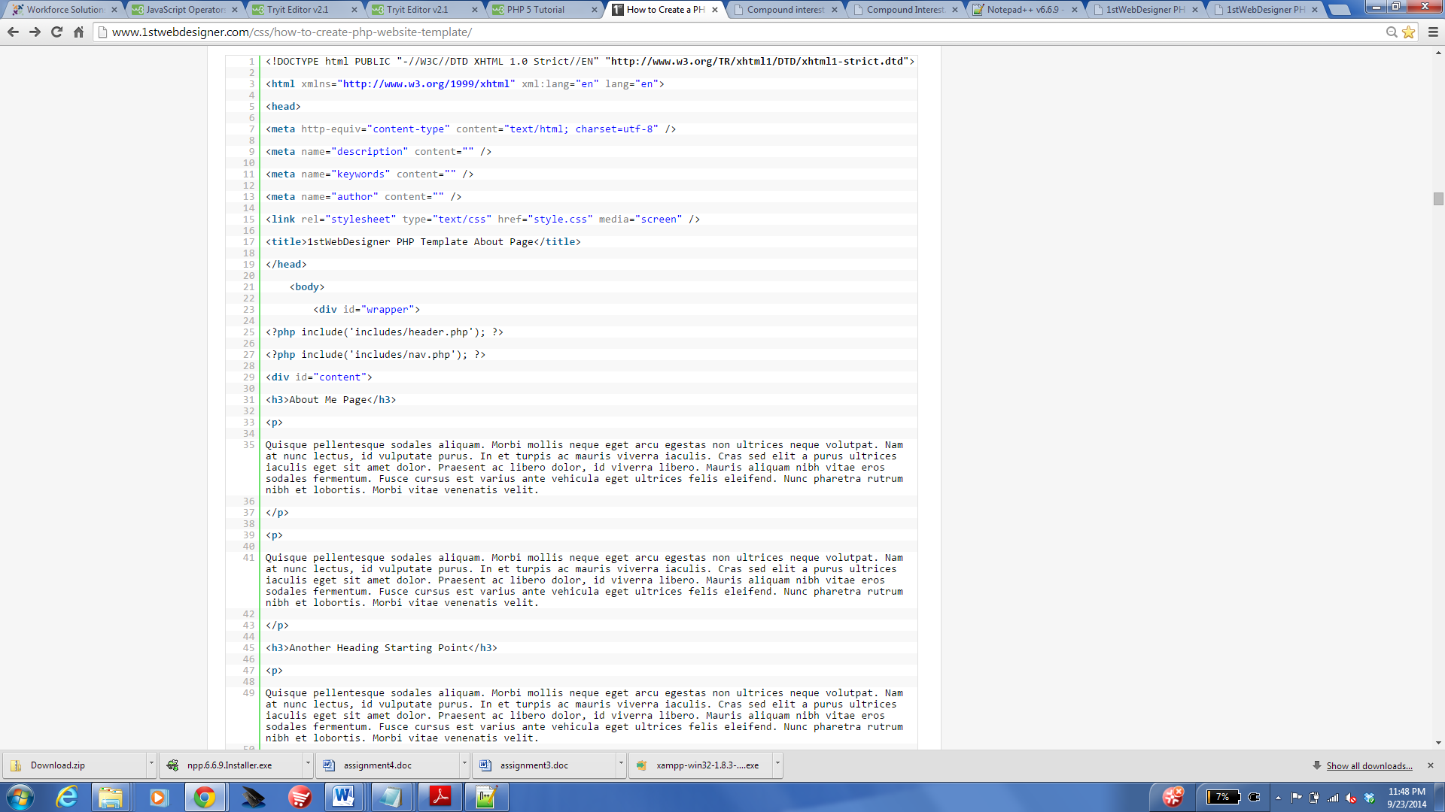

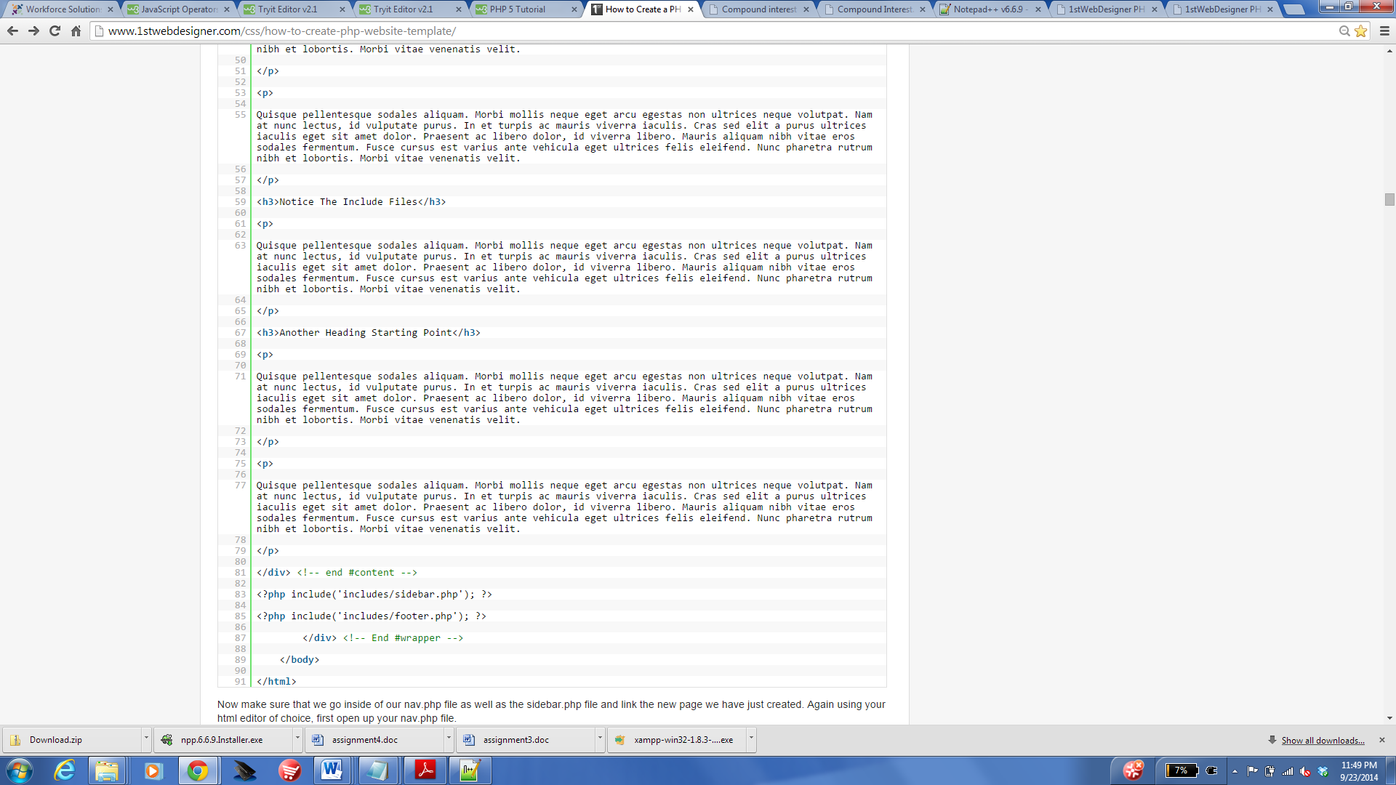

Now make sure that we go inside of our nav.php file as well as the sidebar.php file and link the new page we have just created. Again using your html editor of choice, first open up your nav.php file.

Updating the links should make your file now look like this example below:

#### nav.php

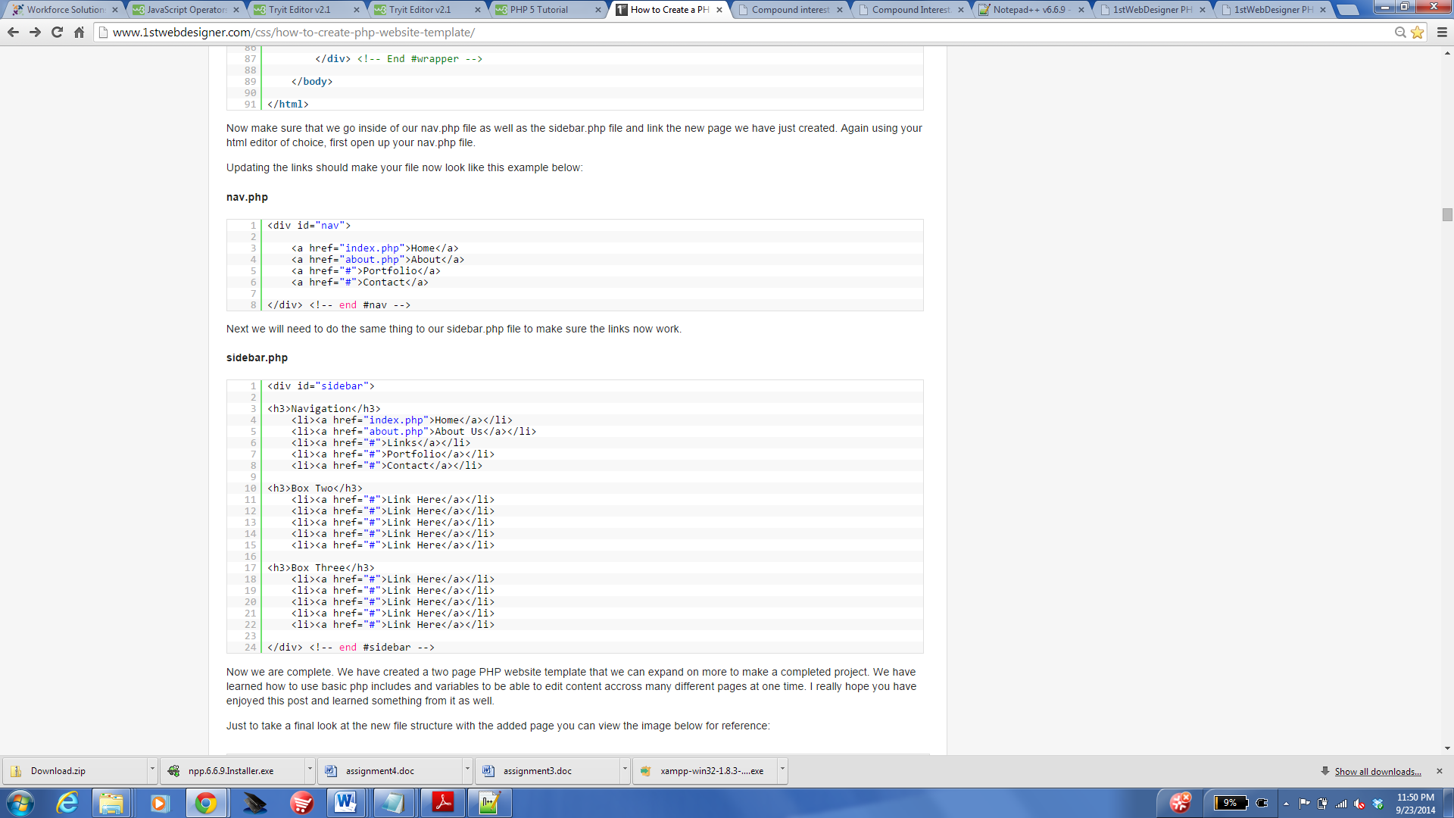

Next we will need to do the same thing to our sidebar.php file to make sure the links now work.

#### sidebar.php



Now we are complete. We have created a two page PHP website template that we can expand on more to make a completed project. We have learned how to use basic php includes and variables to be able to edit content accross many different pages at one time. I really hope you have enjoyed this post and learned something from it as well.

Just to take a final look at the new file structure with the added page you can view the image below for reference:

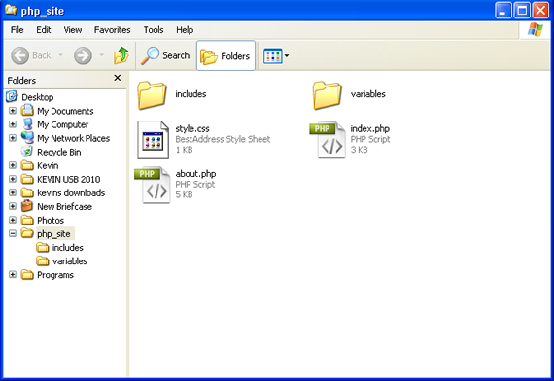

This tutorial was created to give you some basic knowledge on php and creating a php website template.

Reference: <http://www.1stwebdesigner.com/css/how-to-create-php-website-template/>